Understanding Israel – Questions for discussion

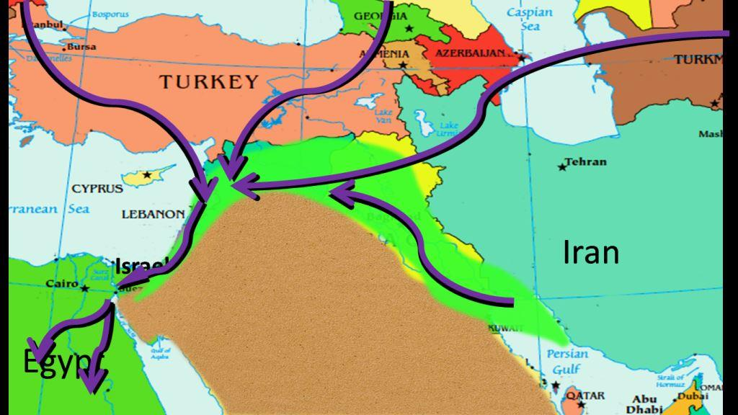
Part 1 – Bird’s Eye View.
1. Look at Matthew 6:25-27. How is this passage enriched by what Andy told us about the bird migration? Do you see any dangers to the bird ecology that they all have to funnel down through Israel?
Look at this video clip of what some people are doing to migrating birds
https://www.youtube.com/watch?v=hIuF_syozzU
youtube.com/watch?v=kZiYaZWSgSU

2. What were the benefits and drawbacks of living as Israel did on a route so favoured by armies and traders? Why so you think God chose Israel for the Promised Land instead of, say, the south of France?
What are the benefits and drawbacks of living where you do? Where would you most like to live? How would you apply Phil 4:11-13 to where you live?
Andy took us on a flying visit to Galilee, Tel Aviv and the Negev. What do each evoke in you? What does it say that all three occur in one little country? How might that reflect your life?

Part 2 – The Temple Mount
1. Some people claimed that Herod’s Temple was the most beautiful in the Roman Empire. What is the most beautiful building you have ever seen?
2. The temple mount is the holiest place in Judaism and the third-most holy place in Islam. Do you have a “holy place”?
3. Do you have any suggestions for how tensions surrounding the Temple Mount could be reduced?
4. Do you see any principles in the following passage?
“As Jesus looked up, he saw the rich putting their gifts into the temple treasury. He also saw a poor widow put in two very small copper coins. ‘Truly I tell you,’ he said, ‘this poor widow has put in more than all the others. All these people gave their gifts out of their wealth; but she out of her poverty put in all she had to live on.’ Some of his disciples were remarking about how the temple was adorned with beautiful stones and with gifts dedicated to God. But Jesus said, ‘As for what you see here, the time will come when not one stone will be left on another.” (Luke 21:5-6)

Part 3- Underground in Jerusalem
1. Sennacherib king of Assyria came and invaded Judah. He laid siege to the fortified cities, thinking to conquer them for himself. But Hezekiah blocked the the Gihon spring and channelled the water down to the west side of the City of David. 2 Chronicles 1, 30.
What do you think about this achievement? Is there a spiritual principle here?
2. Some Jews like to pray as close as possible to the site of the Holy of Holies as possible. Do you think place is important in our spiritual lives?
3. Do you think there is evidence in in Chronicles 7:1-3, 14-16 to suggest that God’s presence is still at the Temple Mount? Do you believe that God’s presence can be more in one place than another?

More to follow…

